**Lab 7 Activity 2 - Creating and Formatting a Table**

**Objective:** Learn to create and apply formatting to tables in Excel.

1. Enter sample student data, including names, roll numbers, and marks.

2. Highlight the data and click "Format as Table."

3. Apply a predefined table style and adjust column width.

4. Use bold, italic, and font color features to enhance readability.

5. Save and close the file.

**Solutions:**

**Task 1:**

* Open **Microsoft Excel** and create a new workbook.
* In **Cell A1**, type: Roll Number
* In **Cell B1**, type: Name
* 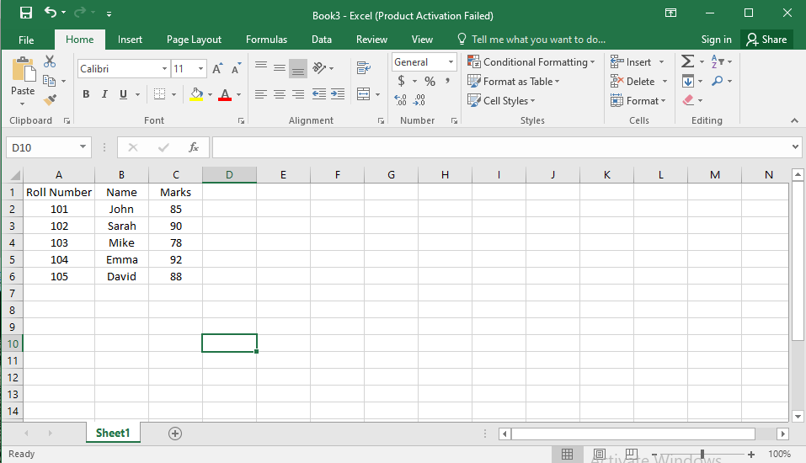In **Cell C1**, type: Marks

**Task 2:**

* 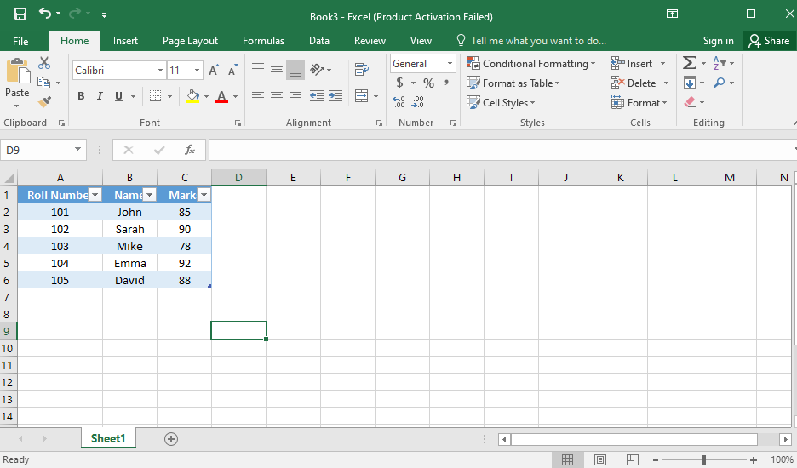Select the entire data range, including headers (e.g., A1:C6).
* Go to the Home tab.
* Click on Format as Table in the Styles group.
* Choose a predefined table style (e.g., blue, green, or any preferred style**).**
* Ensure "My table has headers" is checked and click OK.

**Task 3:**

* Move your cursor to the line between Column A & B (at the top).
* Click and drag to widen the column for better visibility.
* Repeat this for Columns B and C as needed.

**Task 4:**

* Select the header row (A1:C1) and apply:

1. Bold (Ctrl + B).
2. Italic (Ctrl + I).
3. 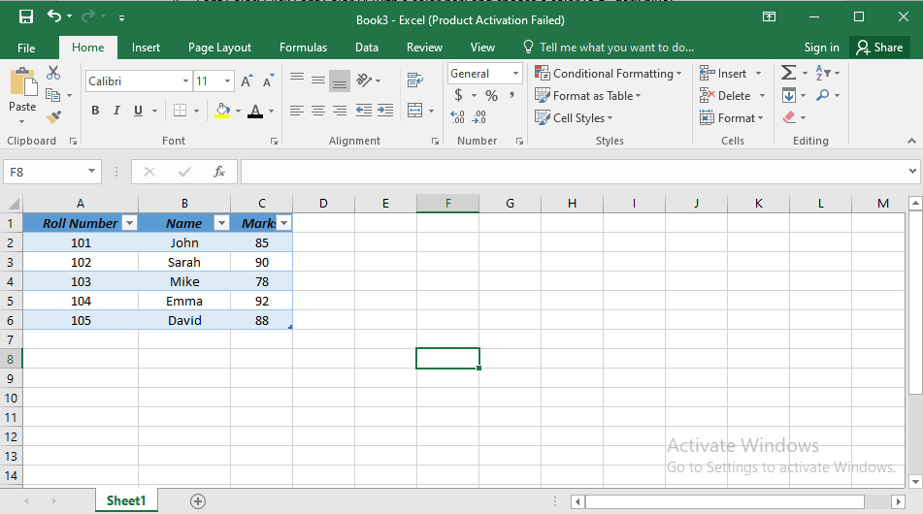Font Color: Click Font Color (A with a color bar) and choose a color (e.g.,black).

**Task 5:**

* Click File > Save As.
* Choose a location (e.g., Desktop or Documents).
* Name the file "Student_Data.xlsx".
* Click Save and close Excel.